PROJECT EXPO-26
PHASE 4: Prototype Development Review (PDR),Deliverables

SECURE MOBILE WEB-BASED REMOTE VOTING SYSTEM

Team Members: Vaishika T.A, Ezhilvizhi R,
Babykarthika S

Working Prototype-Version 1:

  - Home Page
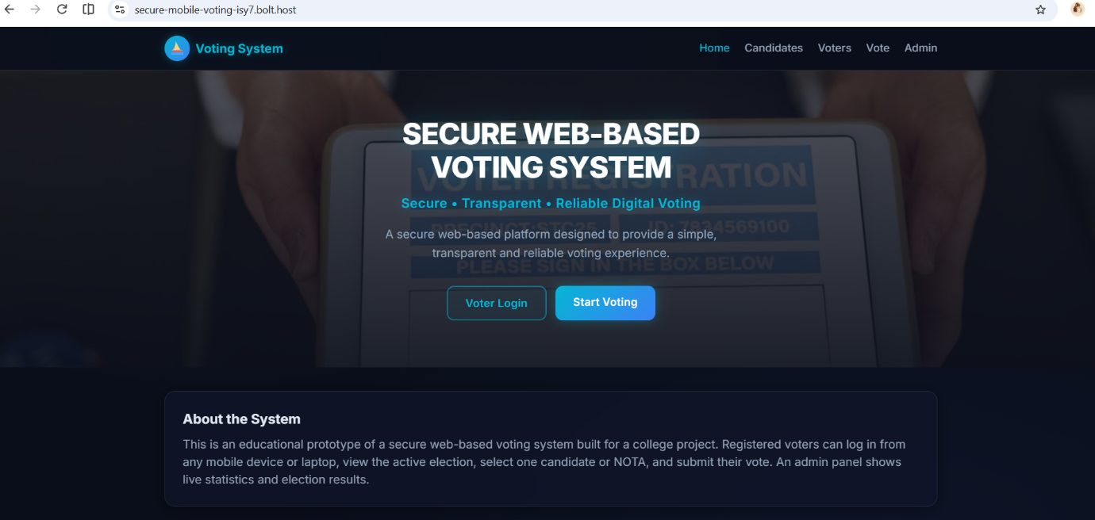
Figure 1: home page of the Secure Mobile Web-based Remote voting system

  - Voter Authentication
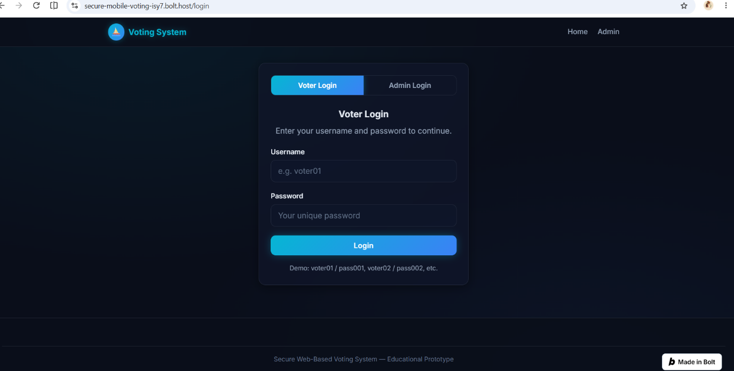
Figure 2: Registered representatives login interface

  - Voter Login
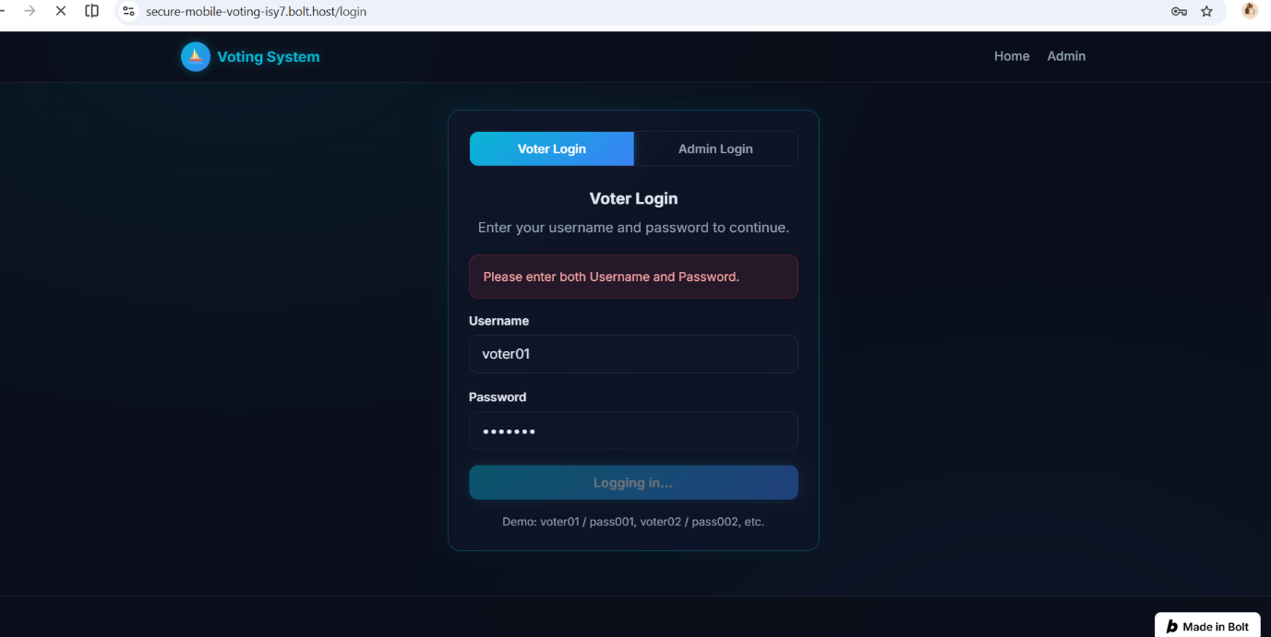
Figure 3: This page features the voter sign-in screen where users enter their username and password to log into the voting system.

1.4 Voter Dashboard
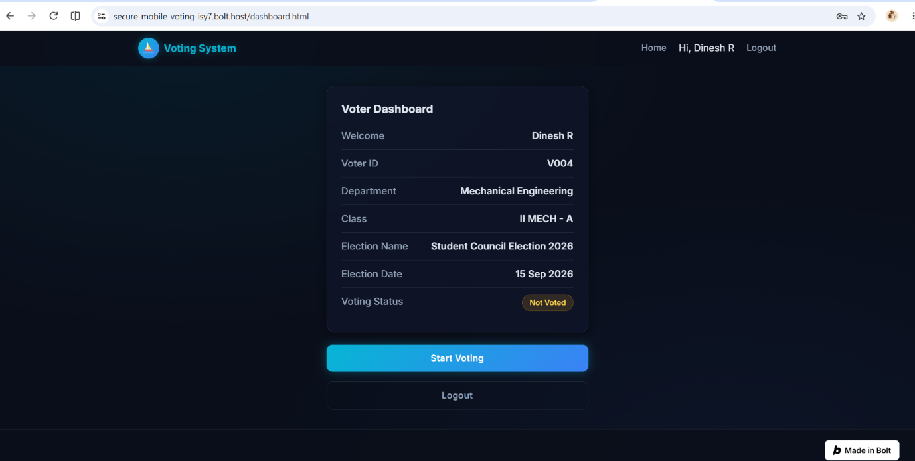
Figure 4: This page displays the voter dashboard containing the user’s profile details and options to start voting.

1.5 Candidate Selection Panel
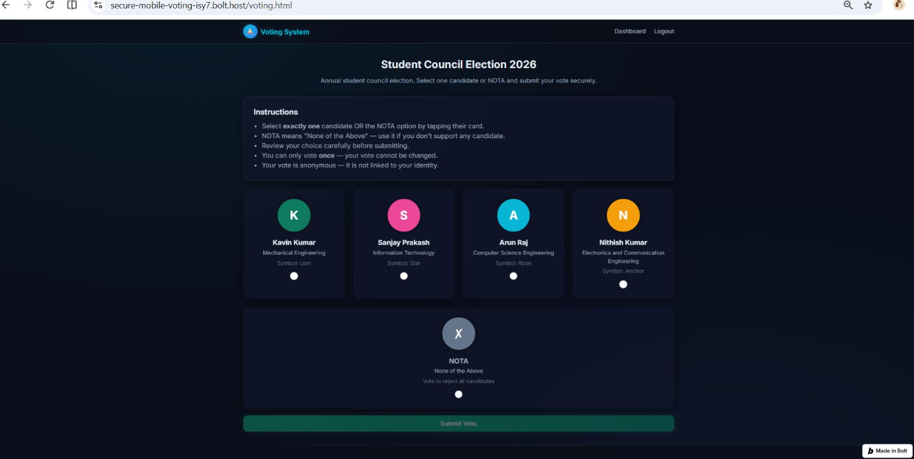
Figure 5: This screen shows the digital ballot interface displaying all eligible candidates available for selection.

1.6 Vote Confirmation Interface
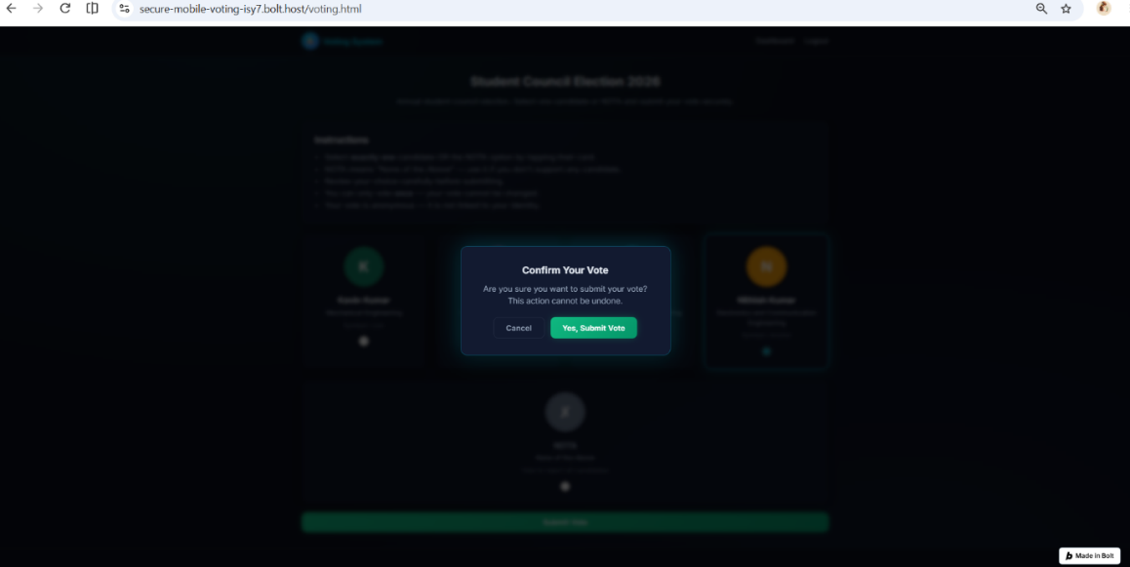
Figure 6: This screen prompts the voter review and confirm their selected candidate before officially submitting the vote.

1.7 Admin Dashboard:
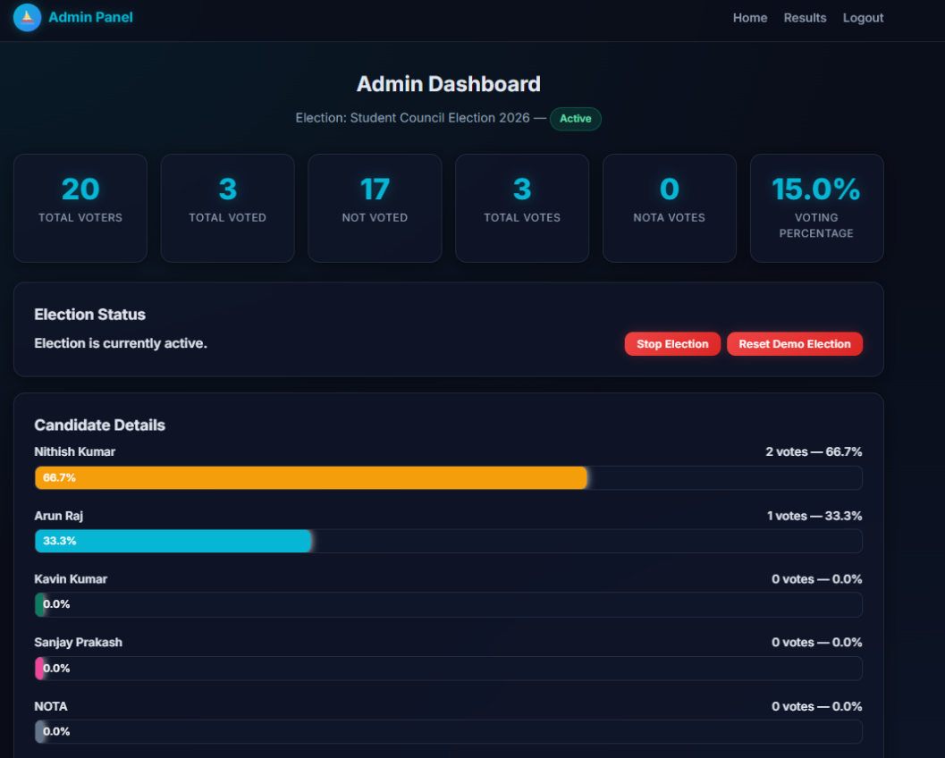
Figure 7: This interface allows administrators to view live voting results, displaying the exact percentage of total votes received by each candidate.

1.8 Session Logout
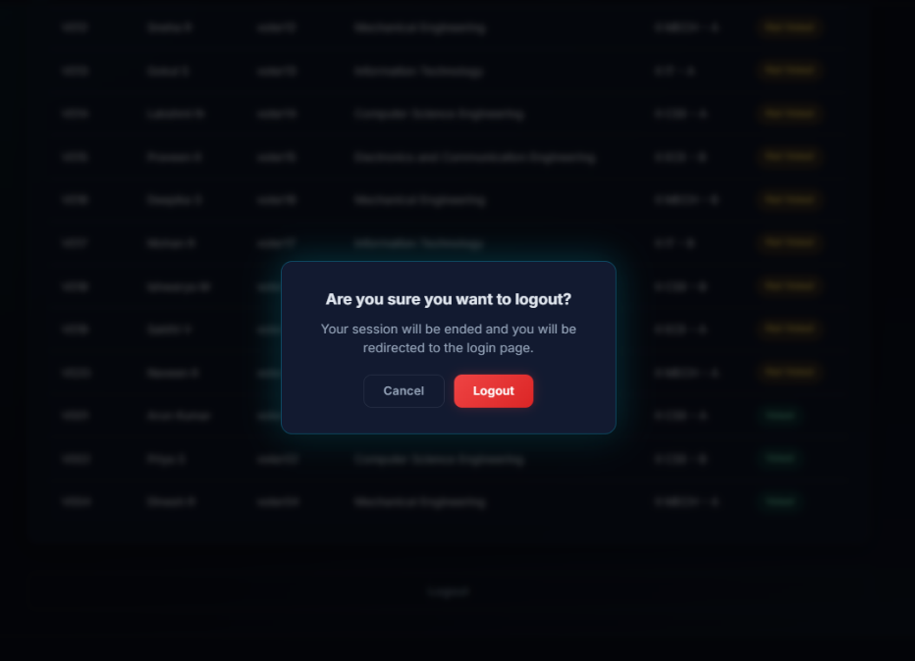
Figure 8: This screen confirms that the user session has been successfully terminated and redirects the user safely back to the home page.
Software Integration:

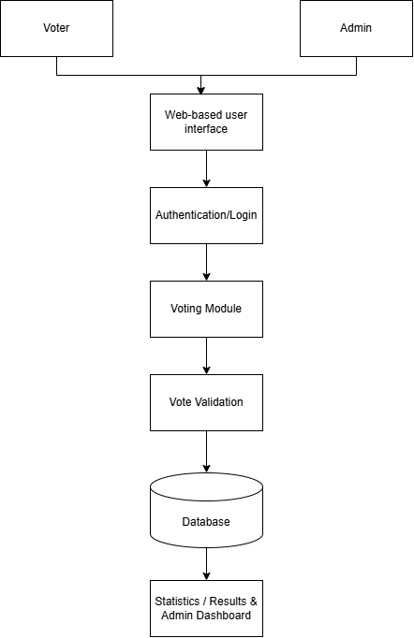

The software integration diagram illustrates how the major components of the Secure Mobile Web-Based Remote Voting System interact. The voter and administrator access the system through the web-based user interface. Authentication is performed before the relevant functions are accessed. The voting module processes the voting activity, while vote validation ensures that the voting process is properly verified. The database stores the required system data, which is used for statistics, results, and the administrator dashboard.

Weekly Progress Report
Project Title: Secure Mobile Web-Based Remote Voting System

Team Details
Department: Electronics and Communication Engineering
Institution: Government college of Engineering
Team Members: Vaishika T A, Ezhilvizhi R, Baby Karthika S

Phase 1 – Problem Identification & Research
Duration: 25 July – 31 July
Objective
To identify the problem to be addressed and study the requirements and challenges associated with remote voting.
Progress Made
- The team discussed and identified the problem area related to remote voting.
- The requirements for a secure and convenient voting system were studied.
- Existing voting approaches and their limitations were discussed.
- The feasibility of developing a mobile-friendly web-based voting system was considered.
- The project objectives and scope were discussed among the team members.
Outcome
The team finalized the problem area and established the basic objectives and scope of the proposed Secure Mobile Web-Based Remote Voting System.

Phase 2 – Concept Development & System Design
Duration: 01 August – 07 August
Objective
To develop the proposed solution and design the basic workflow and structure of the system.
Progress Made
- The overall concept of the proposed remote voting system was developed.
- The major users and functional components of the system were identified.
- The basic voter and representative-related workflow was planned.
- The authentication and voting process were discussed.
- The basic structure and navigation of the web-based system were planned.
- The team discussed how the proposed system could provide a simple and accessible voting experience.
Outcome
The basic concept, system workflow and major functional components were established for further development.

Phase 3 – Hardware/Software Design
Duration: 08 August – 21 August
Objective
To design the software structure and prepare the system for prototype development.
Progress Made
- The project was planned primarily as a web-based software system.
- The major software modules required for the system were identified.
- The voter-related interface and representative-related interface were planned.
- The login/authentication interface was designed.
- The basic voting workflow was structured.
- The user interface of the web application was developed as the initial step towards the prototype.
- AI-assisted web development tools were used to accelerate the development of the prototype.
Outcome
The initial software structure and user interfaces were prepared, providing a foundation for the development of Prototype Version 1.

Phase 4 – Prototype Development
Duration: 22 August – 04 September
Objective
To develop Prototype Version 1 and integrate the major software components of the proposed system.
Progress Made
- Development of the web-based prototype was initiated.
- The main website interface was developed.
- Voter-related pages were created.
- Representative-related information/pages were developed.
- A login/authentication interface was incorporated into the prototype.
- The basic navigation and user flow of the website were developed.
- The prototype was developed using an AI-assisted web development platform.
- The team worked towards integrating the different software components into a single web-based system.
- Initial issues in the authentication and system functionality were identified for further debugging.
Current Status
The web-based prototype is currently being refined. The team is working on completing the authentication and functional integration required for a demonstrable Prototype Version 1.
Outcome
An initial web prototype containing the major interfaces and system structure has been developed and is being prepared for further integration and validation.

Current Status
The team is preparing the prototype and required documentation for the final review.

Overall Project Progress
The project has progressed from problem identification and research through concept development, system design and initial web prototype development. The current focus is on completing the functional Prototype Version 1, integrating the major software components and preparing the required evidence for the Prototype Development Review.
Further testing, debugging, performance evaluation and reliability analysis will be carried out during the Testing & Validation phase.

Phase-wise Deliverable Status
Deliverable | Current Status
Working Prototype V1 | In Progress
Embedded Software | Not Applicable
PCB Fabrication | Not Applicable
Mechanical Assembly | Not Applicable
Hardware Integration | Not Applicable
Software Integration | In Progress
GitHub Repository | Existing repository; Phase 4 update pending
Prototype Images | To be prepared after prototype completion
Prototype Video | To be recorded after prototype completion
Source Code | To be added when final project files are available
Weekly Progress Report | In Progress

Future Development
The team will focus on completing the working prototype, improving authentication and software integration, conducting functional testing, identifying and debugging errors, and preparing the final project demonstration and documentation.

GitHub Repository Link : https://github.com/vaishikaTA/Secure_Mobile_Web_Based_Voting_System

